📘 Implementation Steps – Jenkins Pipeline Deployment

Step 1: Log in to Jenkins
- Open the Jenkins UI from the top navigation bar.
- Log in using the admin credentials.
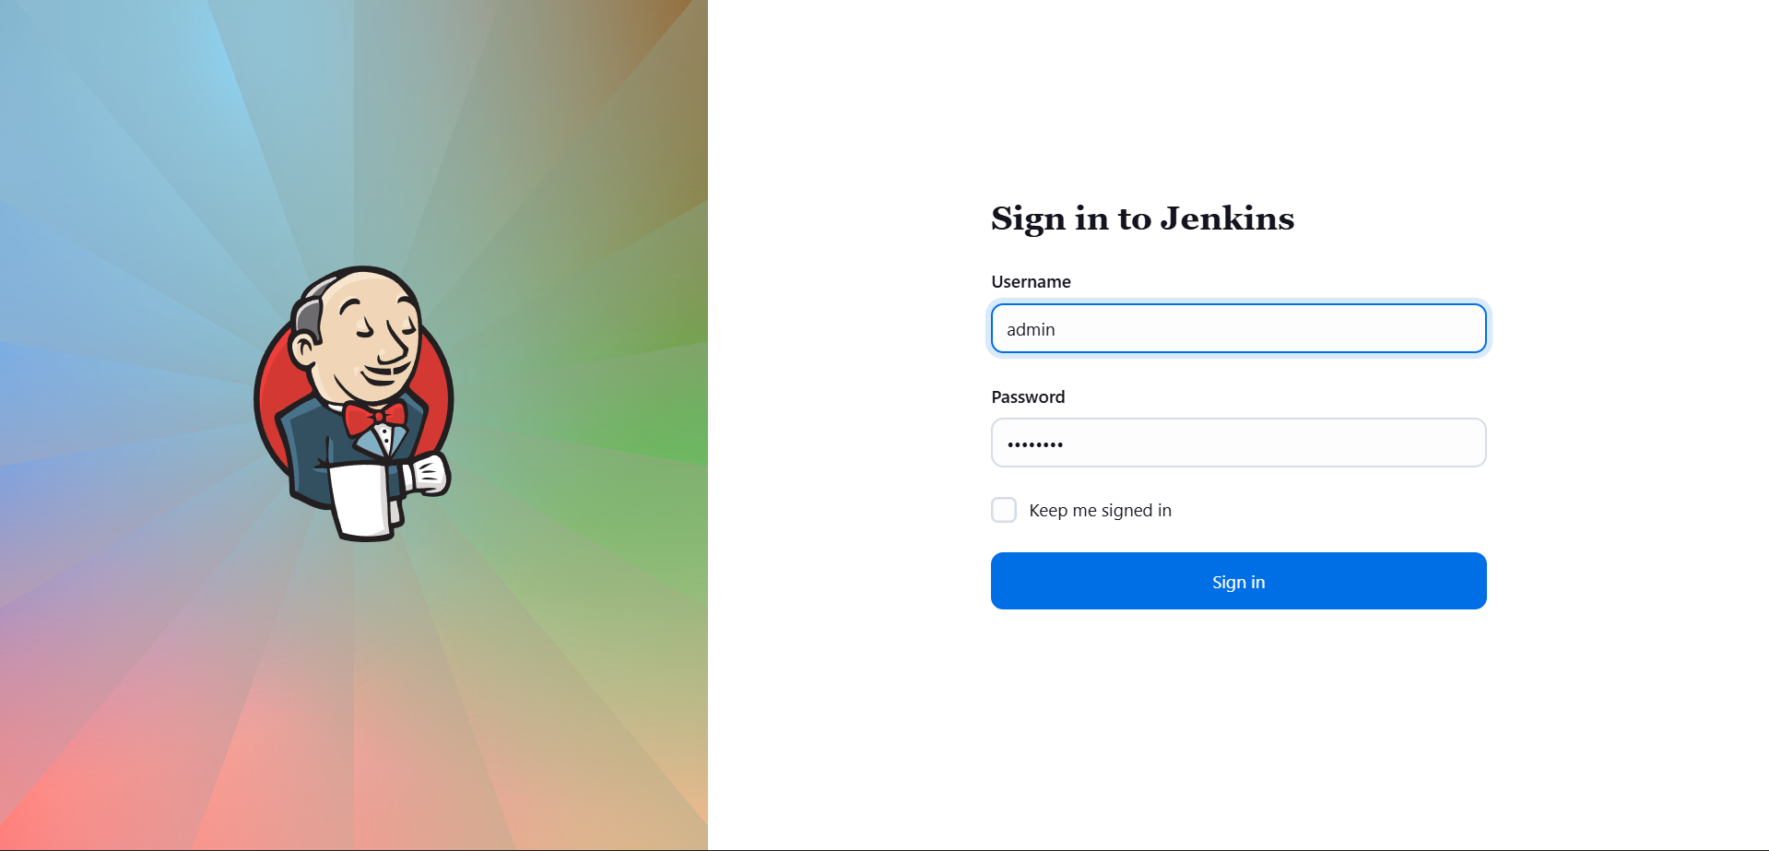
- Ensure access to the Jenkins Dashboard.

Step 2: Log in to Gitea
- Access the Gitea UI from the top navigation bar.
- Log in using the developer credentials.
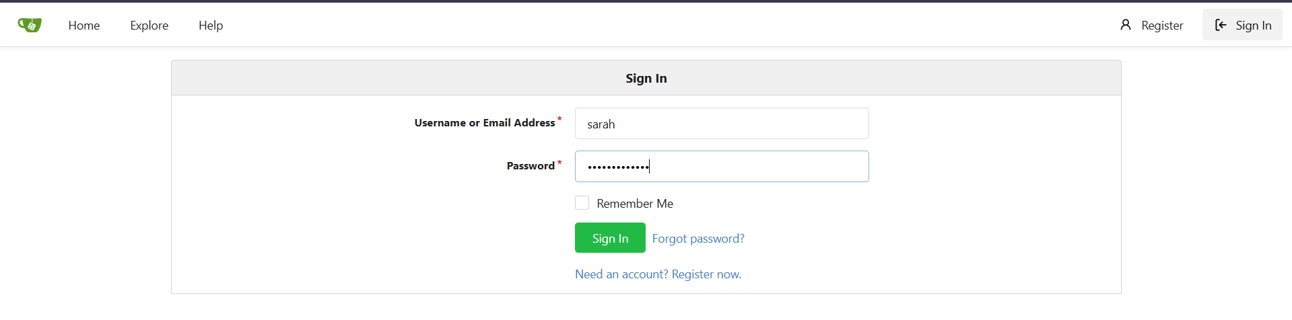
- Verify the repository web_app is available under the developer account and already cloned on the storage server at /var/www/html.

Step 3: Install Required Jenkins Plugins
- Navigate to Manage Jenkins → Plugins → Available Plugins.
- Search for and install the following plugins:
  - SSH Build Agents
  - Git
  - Pipeline
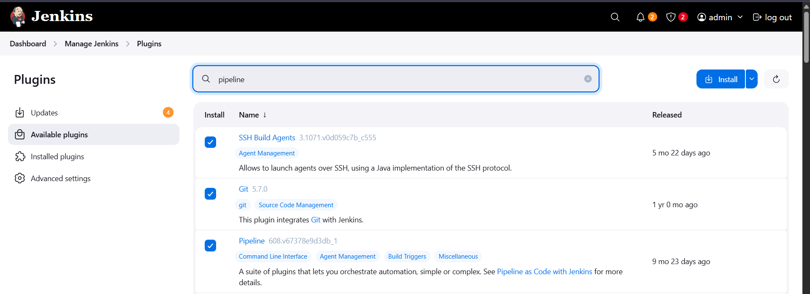
- After installation, restart Jenkins to apply plugin changes.

Step 4: Create and Store Jenkins Credentials
- Go to Manage Jenkins → Credentials → System → Global credentials.
- Add new credentials with:
  - Kind: Username with password
  - Username: natasha
  - Password: corresponding password
  - ID: meaningful identifier (e.g., natasha-id)
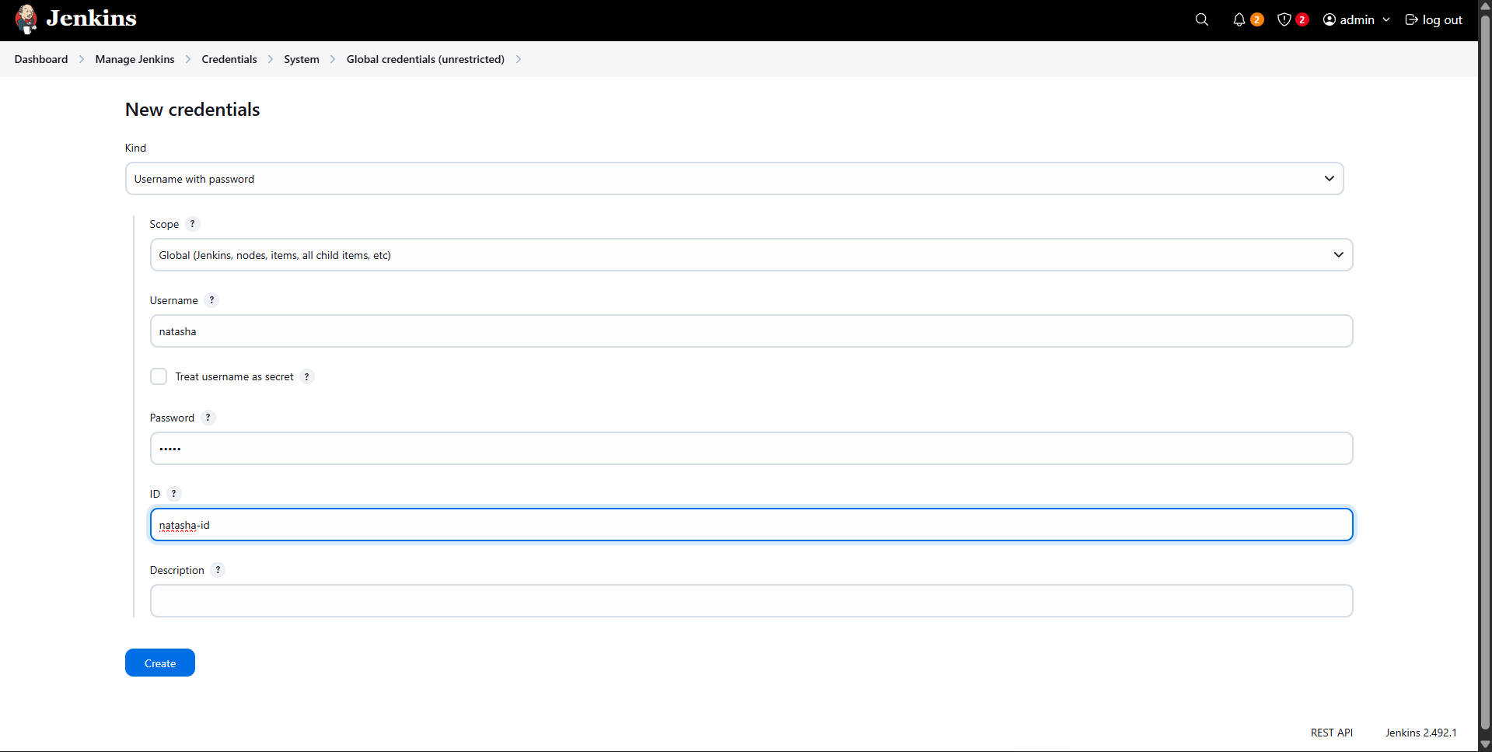
- Save the credentials.

Step 5: Prepare the Storage Server
- SSH into the storage server (ststor01) using the deployment user.
- Update ownership of the web directory so Jenkins can deploy files:
- sudo chown -R natasha:natasha /var/www/html
- Install Java (required for Jenkins agent communication):
- sudo yum install java-21-openjdk -y
- Verify Java installation before proceeding.
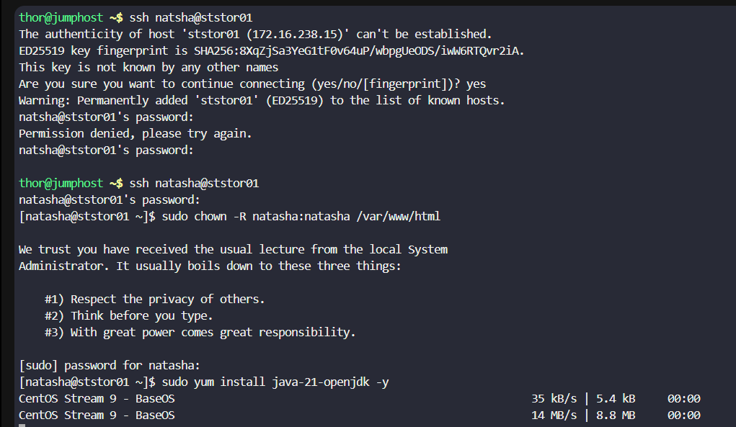

Step 6: Create Jenkins Agent (Node)
- Navigate to Manage Jenkins → Nodes → New Node.
- Configure the node as follows:
  - Node name: Storage Server
  - Type: Permanent Agent
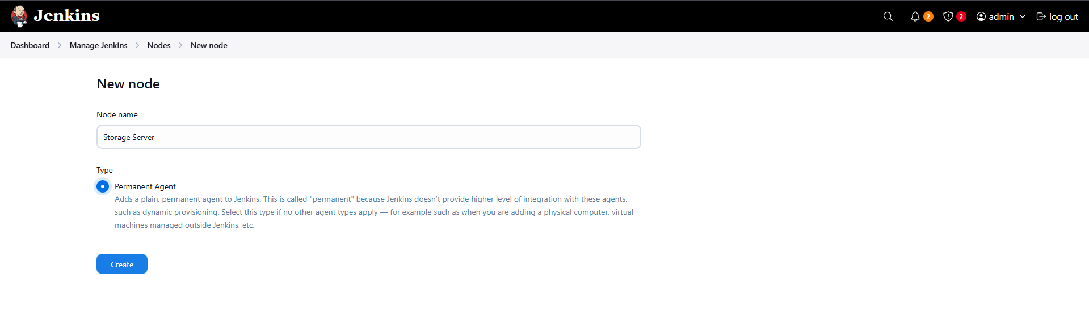
  - Number of executors: 1
  - Remote root directory: /var/www/html
  - Labels: ststor01
  - Usage: Only build jobs with label expressions matching this node
- Configure launch method:
  - Launch agents via SSH
  - Hostname: ststor01.stratos.xfusioncorp.com
  - Credentials: select the stored natasha credentials
  - Host Key Verification Strategy: Non-verifying
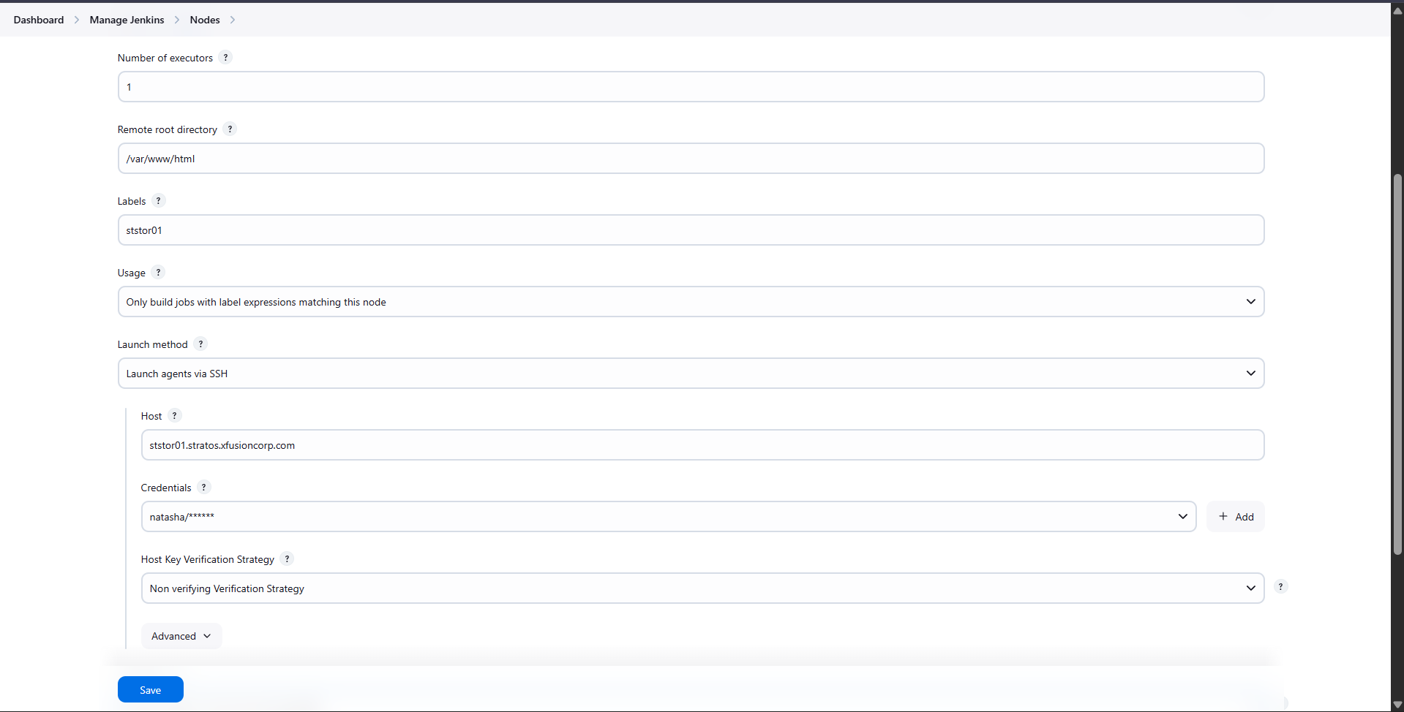
- Save and confirm the agent status shows In Sync.

Step 7: Create Jenkins Pipeline Job
- From Jenkins Dashboard, click New Item.
- Enter job name: datacenter-webapp-job.
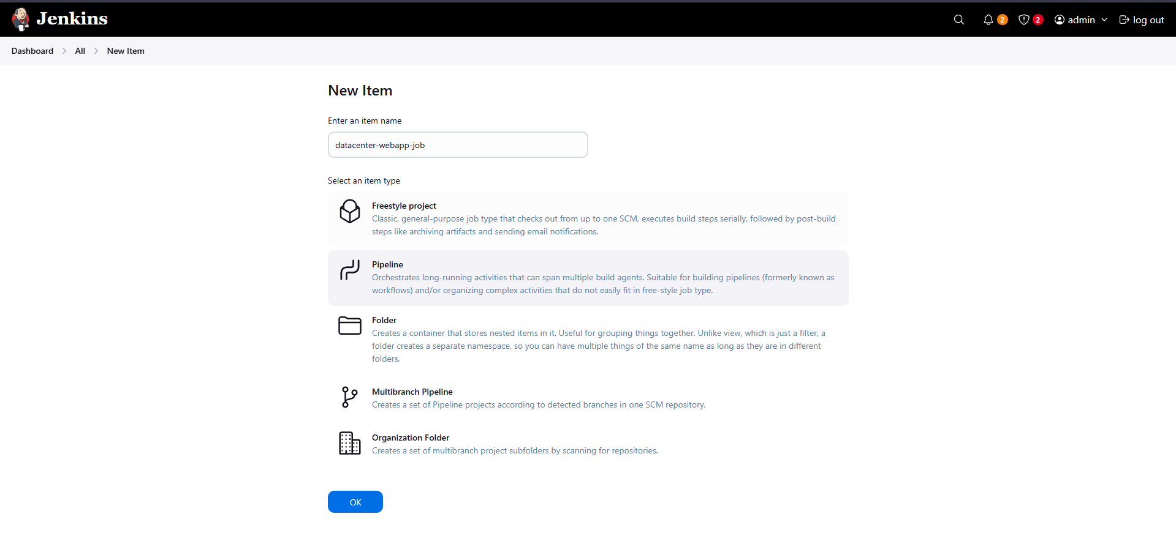
- Select Pipeline (do not select Multibranch Pipeline).
- Click OK.

Step 8: Configure Build Parameters
- Enable This project is parameterized.
- Add a String Parameter:
  - Name: BRANCH
  - Default Value: master
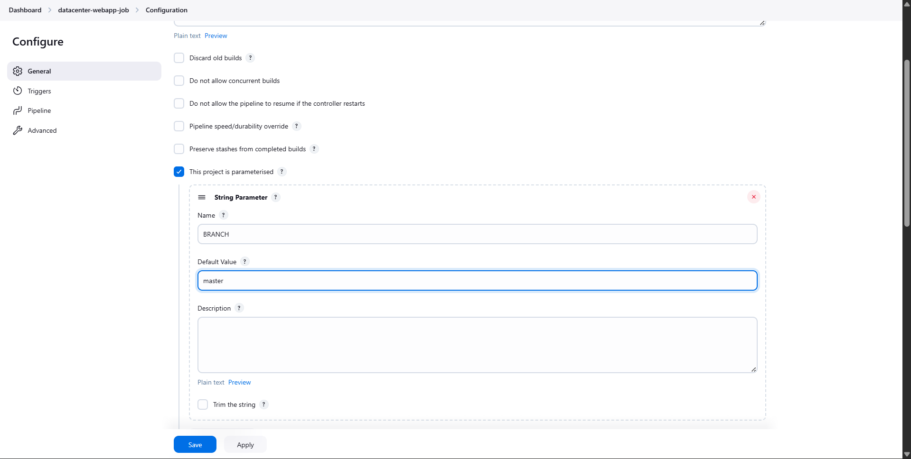
- Save the configuration.

Step 9: Configure Pipeline Script
- In the Pipeline section, add the following Declarative Pipeline script:
pipeline {
agent {
label 'ststor01'
}
stages {
stage('Deploy') {
steps {
script {
if (params.BRANCH != 'master' && params.BRANCH != 'feature') {
error("Invalid BRANCH parameter. Only master or feature are allowed")
}

git branch: "${params.BRANCH}",
url: "http://git.stratos.xfusioncorp.com/sarah/web_app.git"

sh '''
cp -r * /var/www/html/
'''
}
}
}
}
}
- Save the pipeline configuration.

Step 10: Execute Pipeline with Parameters
- Click Build with Parameters.
- Run the job with:
  - BRANCH = master
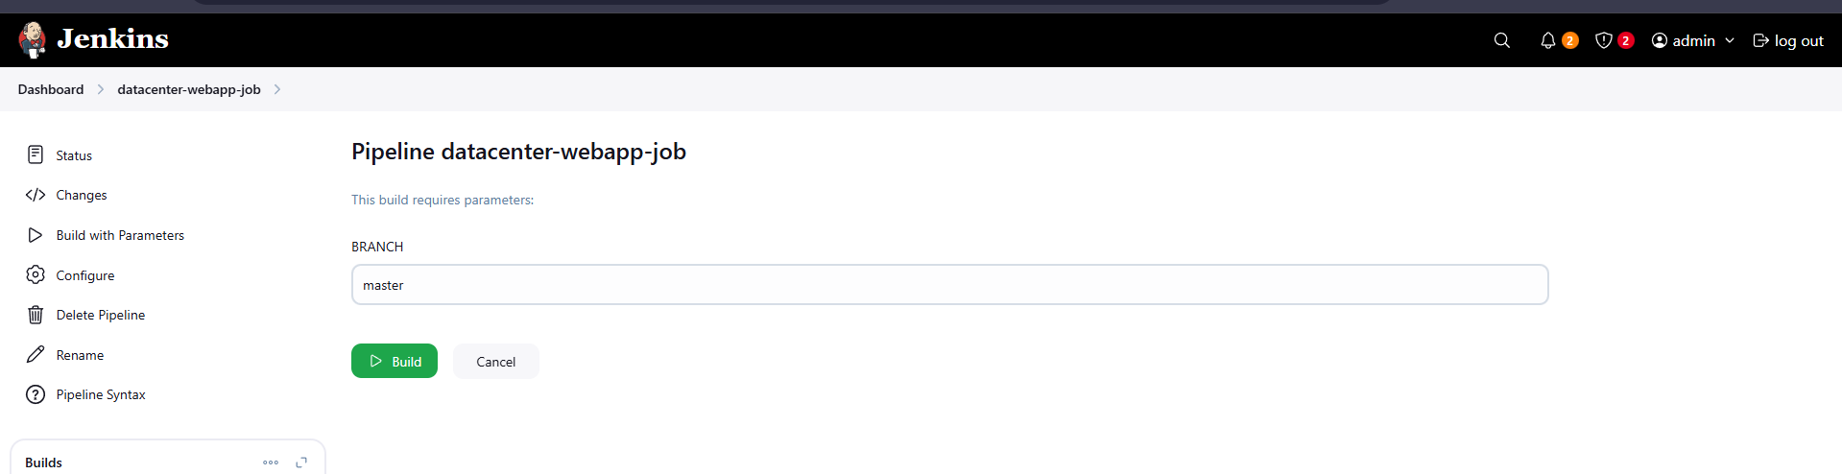
  - BRANCH = feature
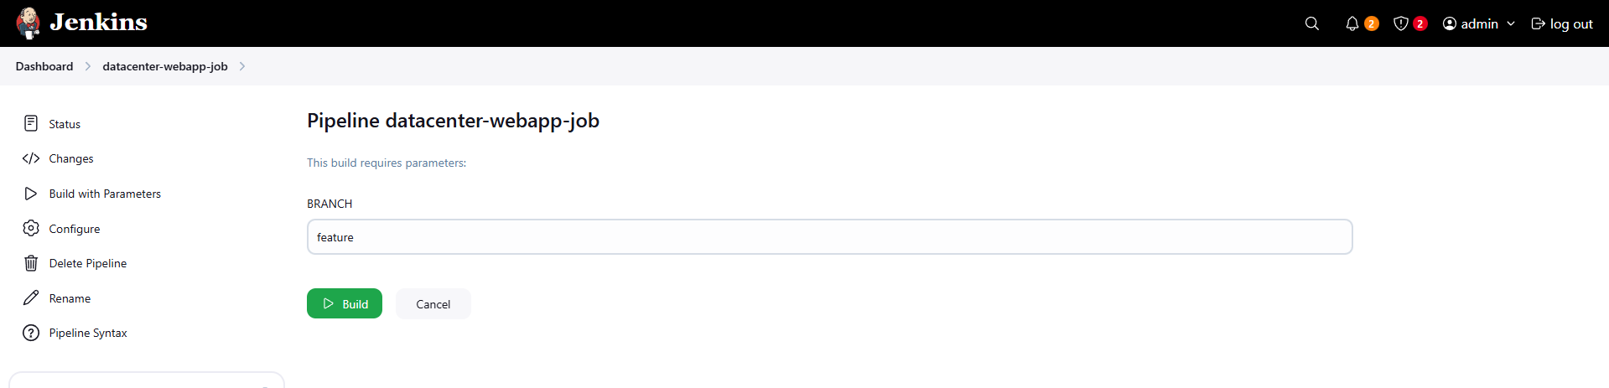
- Verify each build completes successfully.
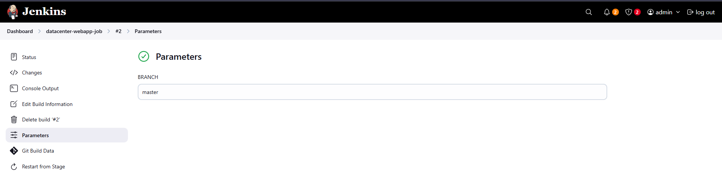
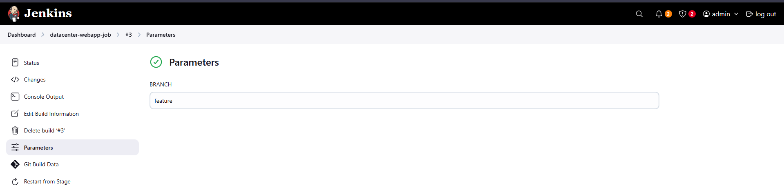

Step 11: Validate Deployment
- Open the application using the Load Balancer main URL.
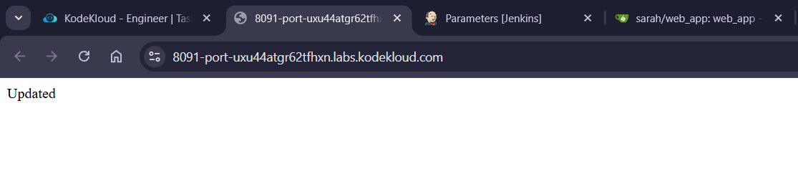
- Confirm that the latest content is loading directly from the root path (/).
- Ensure no sub-directory (e.g., /web_app) is required.

